***“Hands on project on micro milling process”***

Project Report

For

**ME623  
Dynamics of Machining Processes**



Submitted by:

*Group No:5*

Navneet Kumar 236103103

Amit Khare 236103101

Harsha Vardhan P. 234103419

**CONTENTS**

**Chapter - 1: INTRODUCTION**

**Chapter - 2: METHODOLOGY**

**Chapter - 3: RESULTS AND DISCUSSION**

**Chapter - 4: CONCLUSION**

**Chapter – 1**

**INTRODUCTION**

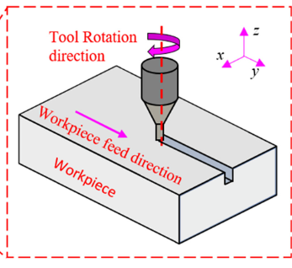To analyze and understand the dynamic behavior of the milling process. This includes investigating the vibrations and accelerations experienced by the milling tool during operation, identifying any patterns or anomalies in the data, and potentially correlating these findings with the quality of the machined surface or other process parameters. The goal is to gain insights into the milling process dynamics and explore opportunities for optimization or improvement based on the accelerometer data collected.

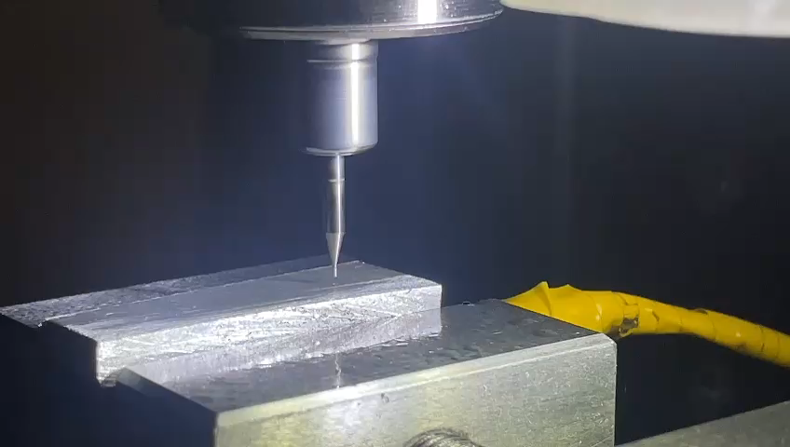Currently, the traditional micro-scale fabrication techniques such as lithography, micro EDM, laser ablation etc. have some limitations in creating complex 3D features in high strength metals and alloys. Micromilling can create 3-D free-form features in wide variety of engineering materials with good surface finish and relatively high tolerance. It is extensively used in manufacturing of micro-scale features for components used in electronics, optics, automotive, biomedical, aerospace, and information technology industries. Micromilling process has some limitations and challenges which need to be addressed for this technology to be proliferated. The diameter of the micro-end mill can be as low as few tens of microns which can result in orders of magnitude lower flexural stiffness as compared to the macro end mills. A significant deflection can be produced in micro tools during machining operation due to this limited stiffness which can resulted in catastrophic tool failure. This is more likely to happen in difficult-tomachine materials like Ti Alloys. This issue of low flexural stiffness can be addressed using high rotational speeds for reducing the chip loads (feed/flute) which can lead to a significant reduction in the cutting forces. Other than the miniature end mill, the rotating spindle/tool holder and toolworkpiece contact are additional sources of flexibility which needs to be accounted for. It may be noted that the limited flexural stiffness coupled with high rotational speeds can induce dynamic instability in micromilling operation because high rotational speeds can amplify the rotational misalignments resulting in dynamic variation in the chip thickness. This dynamic instability is generally termed as regenerative chatter which is a self-excited vibration due to dynamic variation in chip thickness. This regenerative chatter can result in deterioration of the surface finish and catastrophic tool failure, especially, for micro-scale tools.

**Chapter-2**

**METHODOLGY**

**2.1 METHODOLGY AND STEPS FOLLOWED:**

1. **\*\*Setup and Preparation: \*\***

- Mount the 40 mm milling tool securely onto the milling machine.

- Securely clamp the aluminum workpiece onto the milling bed.

- Ensure all safety measures are in place, including proper protective gear and machine safety protocols.

2. **\*\*Slot Milling Process: \*\***

- Begin the slot milling process on the aluminum workpiece as demonstrated in the provided video.

- Maintain consistent feed rates and cutting speeds throughout the milling operation.

- Record the accelerometer data continuously during the milling process to capture vibrations in the x-axis ($a_{x}$), y-axis ($a_{y}$), and z-axis ($a_{z}$) with respect to time.

3. **\*\*Data Collection: \*\***

- Collect accelerometer data throughout the milling operation to capture the dynamic behavior of the milling process.

- Ensure data collection includes variations in cutting parameters such as depth of cut.

4. **\*\*Data Analysis: \*\***

- Process the collected accelerometer data to extract acceleration values in the $a_{x}$, $a_{y}$,and $a_{z}$ directions for different depth of cut.

- Convert the time-domain accelerometer readings into the frequency domain using the Fast Fourier Transform (FFT) algorithm.

- Analyze the frequency spectrum to identify dominant frequencies and amplitudes corresponding to the vibrations induced during the milling process.

**2.1 MATLAB CODE FOR FFT**

Below is the MATLAB code utilized in our project for converting accelerometer readings from the time domain to the frequency domain using the Fast Fourier Transform (FFT):

del_t = 2*1E-5;

Fs = 1/del_t;

load group_5;

A = T1_70doc_30000RPM(:,3);

A = table2array(A);

N = length(A); % Length of Samples

s1 = A(:,1);

S1 = fft(s1);

S1_oneSide = S1(1:(N)/2);

S1_meg = abs(S1_oneSide)/((N)/2);

f = Fs*(0:(N+1)/2-1)/(N+1); % Frequency domain

figure()

plot(f,S1_meg)

**Chapter – 3**

**RESULTS**

We prepared graphs depicting the amplitude versus frequency for each depth of cut utilized during the milling process . in the next step we compared and analyzed the frequency spectra obtained for different depth of cuts to identify trends and patterns. Below are the observations at N = 30000 RPM for different depth of cuts.

**Observation 1: Depth of Cut = 40** **µm, RPM =30000**

Frequency (Hertz)

Amplitude

Fig 1(a) X-direction

Frequency (Hertz)

Amplitude

Fig 1(b) Y-direction

Frequency (Hertz)

Amplitude

Fig 1(c) Z-direction

**Observation 2: Depth of Cut = 50 µm, RPM =30000​**

Frequency (Hertz)

Amplitude

Fig 2(a) X-direction

Frequency (Hertz)

Amplitude

Fig 2(b) Y-direction

Frequency (Hertz)

Amplitude

Fig 2(c) Z-direction

**Observation 3: Depth of Cut = 60 µm, RPM =30000**

Frequency (Hertz)

Amplitude

Fig 3(a) X-direction

Frequency (Hertz)

Amplitude

Fig 3(b) Y-direction

Frequency (Hertz)

Amplitude

Fig 3(c) Z-direction

**Observation 4: Depth of Cut = 70 µm, RPM =30000**

Frequency (Hertz)

Amplitude

Fig 4(a) X-direction

Frequency (Hertz)

Amplitude

Fig 4(b) Y-direction

Frequency (Hertz)

Amplitude

Fig 4(c) Z-direction

Based on the above observations , we can deduce that varying frequencies result in different amplitudes for the acceleration in the x, y, and z directions. These amplitudes indicate the presence of chatter vibration. As there was no dynamometer available in the laboratory, we were only able to generate graphs depicting the relationship between amplitude and frequency. From these graphs, it is apparent that the maximum peak occurring at a specific frequency deviate from the natural frequency, indicating chatter in the x, y, and z directions.

**Chapter-4**

**CONCLUSIONS**

Following key observations can be drawn from this study:

1. The conclusion drawn from the Hands-on project in the micro milling process provides valuable insights into the dynamic behavior of the machining operation.
2. By examining the accelerometer data, it becomes evident how various factors such as tool wear, cutting parameters, and material properties influence the vibration and acceleration patterns during milling.
3. Additionally, the analysis may reveal critical points where excessive vibrations occur, potentially leading to tool breakage or surface defects.
4. Understanding these dynamics enables optimization strategies to be developed, including adjustments to cutting parameters or tool geometries to mitigate vibrations and improve machining performance.
5. Overall, the acceleration analysis serves as a crucial tool for enhancing the efficiency, quality, and reliability of micro milling processes.